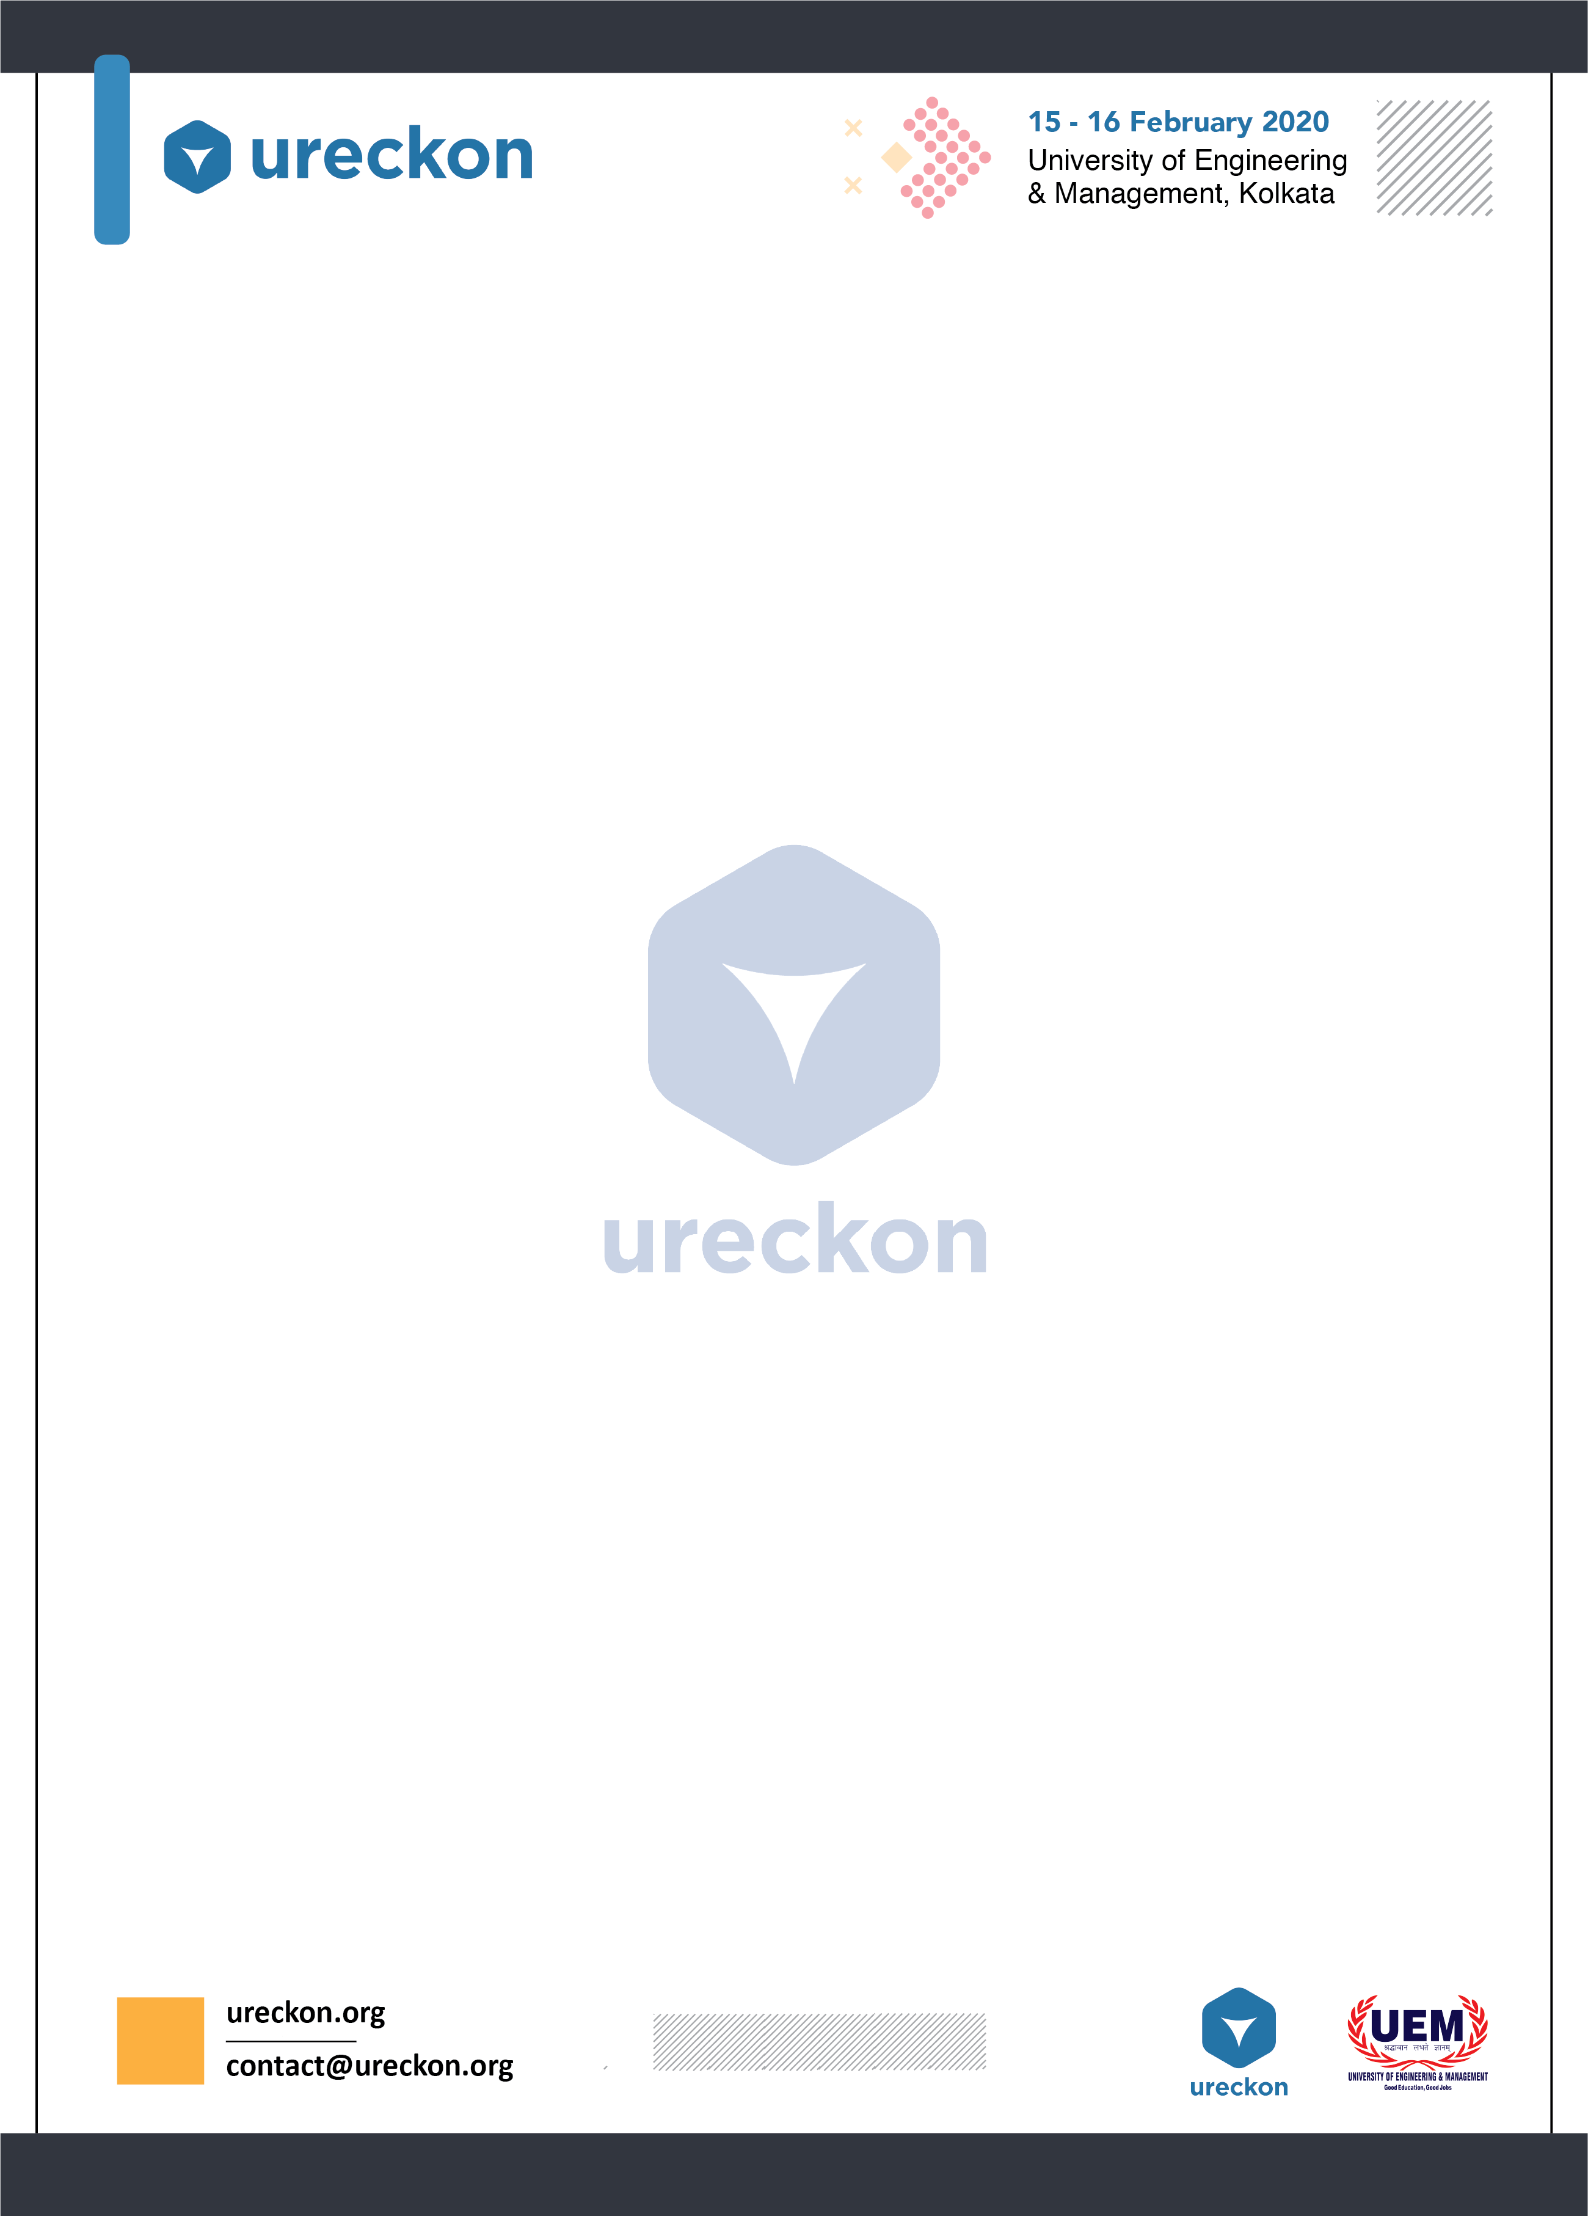

**CLUE-X**

**Life has a way of testing all of us. Every day is a quiz and it demands us to know new things. Every morning that we wake up, we know that we have passed the previous test and it’s time to begin the quest for something new.**

**PROBLEM STATEMENT:**

**ClueX** is the school level quiz event of **URECKON 2020** comprising of 6 thought-provoking rounds.

**RULES & REGULATION:**

* A team can have a maximum of 2 members.
* The use of calculators, mobile phones or any other electronic gadgets is strictly prohibited.
* If any team is caught cheating or adopting any unfair means, then the team might be subjected to immediate disqualification.
* Each round will have a specific marking system that will be informed on the spot.
* The time limits of each round will also be mentioned on the spot.

**DAY-WISE ROUNDS:**

**DAY- 1:**

**Round 1 – APT IT UP**

* The questions in this round will be based on general aptitude and logical reasoning.
* Each team will be provided with a sheet of paper where they need to write the answers.

**Round 2 – PICTURE PERFECT**

* As the name suggests, in this round a picture or a video clip will be displayed and a question will be asked accordingly.

**Round 3 – FAST AND FACTUAL** 

* The questions in this round will be based on scientific facts and figures which might include anything beginning from an important invention or discovery to the rejection of a theory.



* Each team will be provided with a buzzer. To answer a question, they have to press their respective buzzers.

**DAY- 2:**

**Round 4 – GOOGLY**

In cricket, a **googly** is a type of deceptive delivery bowled by a right-arm leg-spin bowler. Why not do something like that in quizzes as well!

* The questions in this round will be deceptive, better to say that the answers will be hidden in the question.
* No options will be given in this round.
* The teams can ask for two hints at max and they will be marked accordingly.

**Round 5 – COGNITION**

* This is a general knowledge round and questions can be asked from any subject, not necessarily belonging to science background.
* The teams will get to choose the field from which they want the question to be asked.
* Options will be provided in this round.

**Round 6 – RAPID FIRE**

* 16 questions on basic topics will be asked in 2 minutes to the teams who will make it to the final round.
* The team that will be able to answer the maximum number of questions correctly, will become the winner.
* In case of a tie, there will be a tie-breaker round.

***Disclaimer: Rules are subjected to change without any prior information.***

***In case of any queries call, WhatsApp or email the co-ordinators.***

**EVENT CO-ORDINATORS:**

**Avinandan Mukherjee: (+918981814735) /(+917980303741)/** [**rivu2mukherjee@gmail.com**](mailto:rivu2mukherjee@gmail.com)

**Somlina Ghosh Ray: (+918017424905)/** [**somlina0320@gmail.com**](mailto:somlina0320@gmail.com)